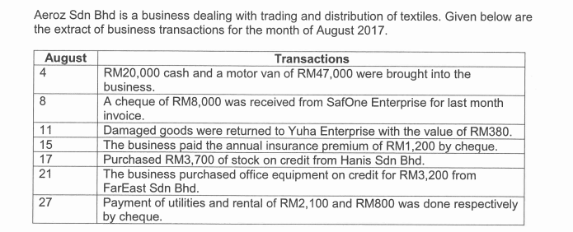
QUESTION 1

REQUIRED:
Illustrate the effects (increase/decrease) of asset, liability, owner's equity, income and
expense of the above transactions
(Use the format given below to answer the above questions)
 | INCREASE | DECREASE
Date (August)
4 | Asset- Cash
 | Asset – Motor van
 | Owner’s Equity - Capital
 | Owner’s Equity - Capital

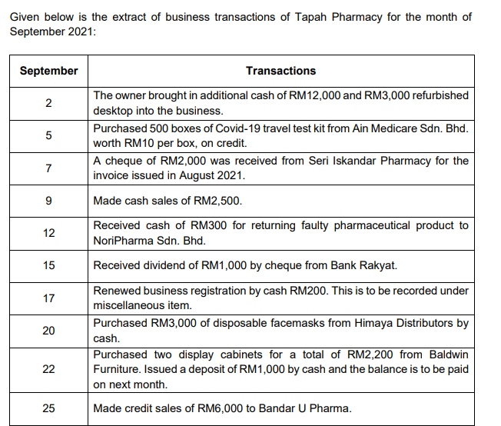
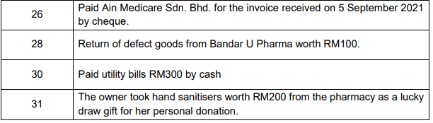

REQUIRED:
Illustrate the effects (increase/decrease) of asset, liability, owner's equity, income and
expense of the above transactions
(Use the format given below to answer the above questions)
 | INCREASE | DECREASE
Date

